PHPUnit – Eclipse Integration

PHPUnit can be integrated into Eclipse environment via “External Tools Configurations” feature of the Eclipse IDE. Firstly, you should open the “External Tools Configurations” window through the path “Run->External Tools-> External Tools Configurations...” as follows:

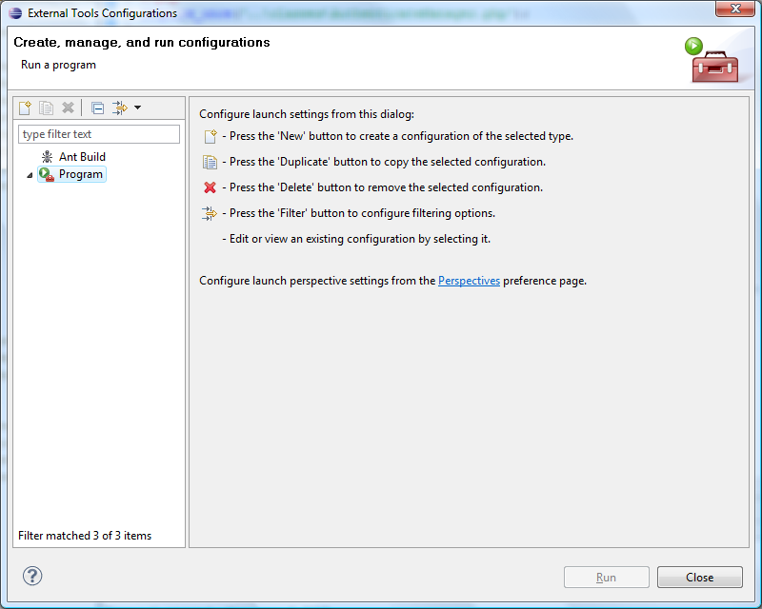

Here you should select the option and then click on “New launch configuration” button (). Then give “PHPUnit” as the name of the new configuration. Moreover you should specify the path for the phpunit.bat file and the path for your unit tests location as below:

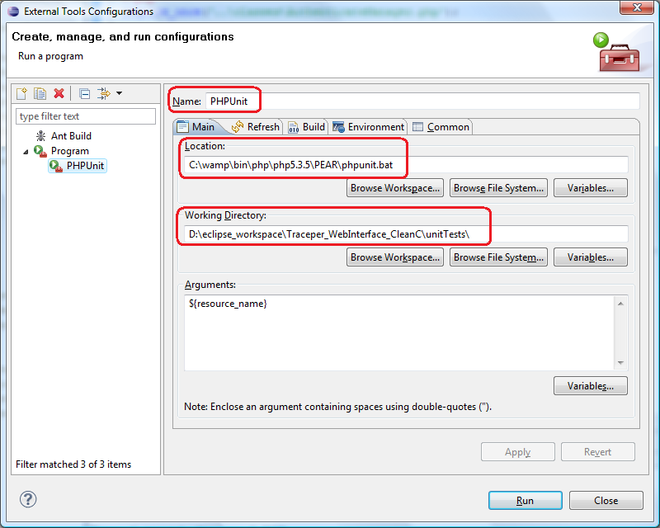

Lastly, the “Arguments” part of the configuration windows should be set as $(resource_name). This could be set by the “Variables...” button as below:

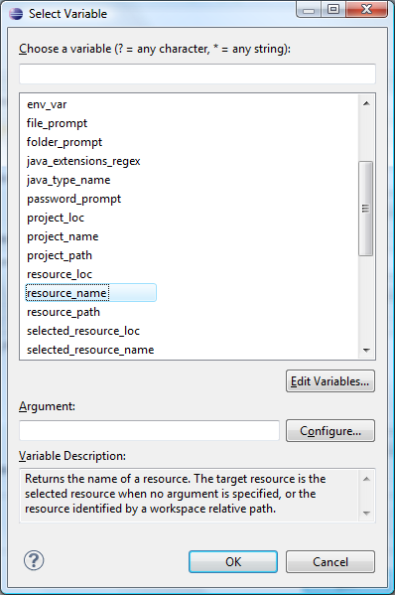

After these settings are done, you should apply them and close the window. From now on you can run your phpunit tests by selecting the test file from the explorer and clicking the “Run external Tools” button () which is in this case “Run PHPUnit”:

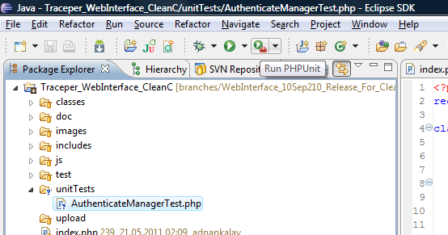
The results are shown at the “Console” window:

